**AZURE SERVICES**

**Azure Services**

* Azure Active Directory
* Azure CDN
* Azure Data Factory
* Azure SQL
* Azure Function
* CosmosDB
* DevOps
* Azure Backup
* Logic Apps
* Virtual Machine

**Azure Active Directory (AD)**

* It’s a cloud-based **Identity as a Service (IDaaS)**, an identity solution to organizations.
* This feature is used in **Office 365** to allow various organizations to setup **single sign-on (SSO)**, will be discussed later.
* Also provides features for allowing organizations to **integrate** cloud services with their **own applications**.
* It provides a feature designed for IT admins to control **security** & **resources**.
* This includes **life-cycle** & **privilege controls** to individuals.

**Azure Content Delivery Network (CDN)**

* Azure has its own network for delivering content.
* It allows all related sources to deliver & receive **high-bandwidth** **content**.

Working:-

* **Azure CDN** is activated when a user requests access to file using **Azure related URL**.
* Then **DNS** directs the request to nearest **point-of-presence (POP)**.
* **Point-of-presence:** Geographically **proxy** networks.
* Then it is checked if ***edge servers*** (nearest servers) contain those files being requested in their **cache**.
* If **not**, then it is checked from the ***origin server***.
* This **origin server** can be anything starting from Azure’s **web app** to its **storage account** etc.

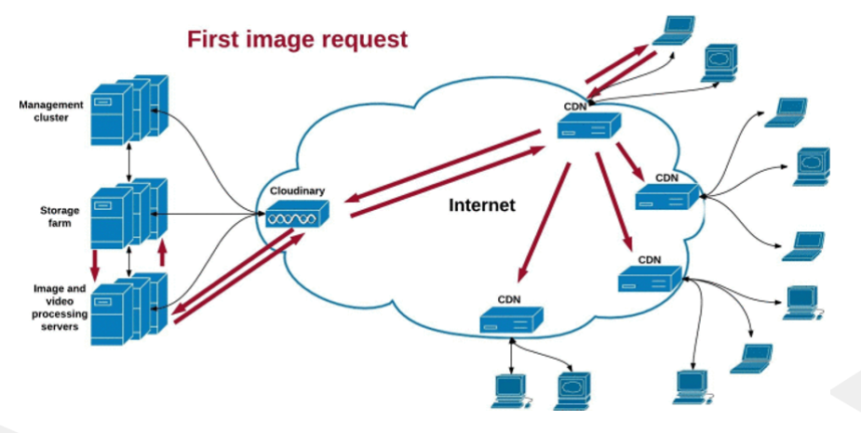

**Azure Data Factory (ADF)**

* **ADF** is responsible for having a **smooth workflow** of data.
* It does so by receiving data from the **routes** it is travelling through.
* Facilities used by ADF:
  + ***Azure Machine Learning***
  + ***Azure HDInsight Hadoop***
  + ***Azure Data Lake Analytics***

**Azure Hadoop**

* ***Apache Hadoop*** is one type of ***cluster*** (tool) in ***Azure HDInsight***.
* It uses **Azure Hadoop** **distributed file system** (HDFS).

**Azure Backup**

* Uses application called ***VSS Snapshot*** in **Windows** & **Linux** for storing log record.

Advantages:-

* Scalable
* Unlimited data transfer
* Centralized monitoring & management
* Automated storage option
* Multiple storage option

**Azure Virtual Machine**

* Used in testing & deployment of **cloud computers**.
* These **VMs** can be bought by users too when required after paying an **extra price**, as well as **shut down** when **not** required anymore.

Types of Azure VM:-

* General purpose
* Compute optimized
* Memory optimized
* GPU-based VM (for **ML** & **graphics processing**)

Key features:-

* Different types of **VMs**.
* **VM configuration**, enabling users to choose number of **CPU cores** & **RAM**.
* **Virtual networking** using **public** or **private IPs**.
* **Distribution of VMs** to various servers nearby to **increase redundancy**.
* **Auto scaling** feature to allow increasing or reducing number of VM instances as per the **traffic**.
* **Replicated disks** as backup.
* Availability of **variety of images** for various OSes.
* **Backup recovery**.
* **Extensions & frameworks** for easy integration.
* **Management & monitoring tools** for tasks like automation and update manager.

**Azure App Service**

* Fully managed **platform-as-a-service** (PaaS).
* Developers can **build**, **host** & **scale** web applications.

Key features:-

* For web apps, supports various programming languages & frameworks **in backend**.
* For mobile apps, provides **backend infrastructure** supporting authentication, push notification, offline sync & data storage.
* And supports **RESTful APIs**.
* It has an **automated scaling system**, which scales the web app as per need without developer intervention, though they can **manually** do that too.
* Developers can **deploy apps directly** from services like **Git**, **Azure DevOps**, **Docker** containers or even from **Visual Studio**.
* Also, it supports **linking of custom domain** to developed apps & secure them using ***SSL certificates***.
* **Authentication** using **Azure AD**.
* Changes can be added to **staging** before final push.

**Azure Storage**

Key components:-

* **Blob storage:** Used to store **unstructured binary** and **text data** like images & videos etc, serving as **static** content on web app.
* **File storage:** Files on Azure’s server can be accessed via **Server Message Block (SMB)**, also allowing **concurrent access** by multiple VMs.
* **Table storage:** Uses custom **NoSQL** DBMS called ***Azure Table Storage*** & stores **non-relational** data.
* **Queue storage:** Allows applications to **asynchronously** communicate among various components.
* **Disk storage:** Storage disks that can be attached to VMs as OS disks.

**Azure Functions**

* A **serverless** computing service.
* These also **scale on demand**.
* **Serverless** here means that the service provider (Microsoft) manages the servers, **not** the consumers.

Key features:-

* **Event-driven execution:** Ability to be executed when certain event is triggered.
* **Languages:** Supports wide variety of programming languages like C#, JavaScript, Python, TypeScript, Java & PowerShell etc.
* Such a **serverless** but **scalable** service makes sure that users pay price for what they are actually using.
* Supports ***stateless*** (static) & ***stateful*** (dynamic) execution.
* **Stateless** functions **don’t** change their state between two executions.
* **Easy integration:** With other Azure services.
* Vast variety of deployment options.
* **Monitoring features:** To monitor function’s performance & insights.
* **Security & authentication:** Uses Azure AD & API keys etc.

**Azure SQL Database**

* Microsoft has its own SQL server.
* Provides high level of security & performance.
* Users can store data on cloud **without** worrying about **manual installation** on local machine.

Key Features:-

* Protection against **data loss** with use of automatic backups, point-in-time restore & active geo-replication.
* **Scalability** of performance.
* All **security measures** including encryption & threat detection etc.
* Database is **automatically patched & upgraded**.
* **Easy integration** with other Azure services.
* **Highly compatible** with **SQL** for running on same servers.
* Contains **built-in tools** like ML models, tools to represent graph & **JSON** support etc.